Handmade Natural Pet Treats using human grade ingredients

Dogs
Bones and Treats in 3 flavours:-
Carrot and Sweet Potato
Peanut Butter
Salmon and Sweet Potato
Small Bones 30p each or 10 for £2.50
Large Bones £1 each or 5 for £4

Treats
100g £5.00 Dog £6.00 Puppy
50g £2.50 Dog £3.00 Puppy
25g £1.50 Dog £2.00 Puppy

Mini Peanut Butter and Banana Dog Muffins 40p each or 10 for £3.50

Cats
Salmon and Sweet Potato nibbles
25g £2.50
10g £1.50

Postage from £2.85 (Delivery in Exeter free)
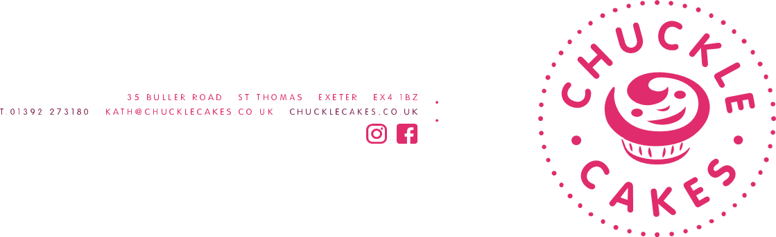

pets can smile too

